PAST AND CURRENT PRESIDENTS OF CYPRUS
# | Name | Portrait | Terms of office |  | Party
1 | Archbishop Makarios III | 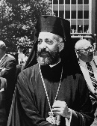 | 16 August 1960 | 15 July 1974  (deposed) | None
- | Nikos Sampson | 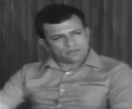 | 15 July 1974 | 23 July 1974 | Progressive Front
- | Glafcos Clerides | 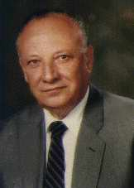 | 23 July 1974 | 7 December 1974 | United Democratic Party
(1) | Archbishop Makarios III |  | 7 December 1974  (restored) | 3 August 1977  (died in office) | None
2 | Spyros Kyprianou | 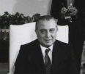 | 3 August 1977 | 3 September 1977 | Democratic Party
2 | Spyros Kyprianou |  | 3 September 1977 | 28 February 1988 | Democratic Party
3 | George Vasiliou | 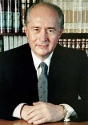 | 28 February 1988 | 28 February 1993 | Independent  supported by  Progressive Party of Working People
4 | Glafcos Clerides |  | 28 February 1993 | 28 February 2003 | Democratic Rally
5 | Tassos Papadopoulos | 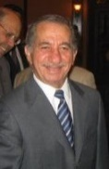 | 28 February 2003 | 28 February 2008 | Democratic Party  supported by  Progressive Party of Working People
6 | Demetris Christofias | 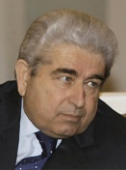 | 28 February 2008 | 28 February 2013 | Progressive Party of Working People
7 | Nicos Anastasiades | 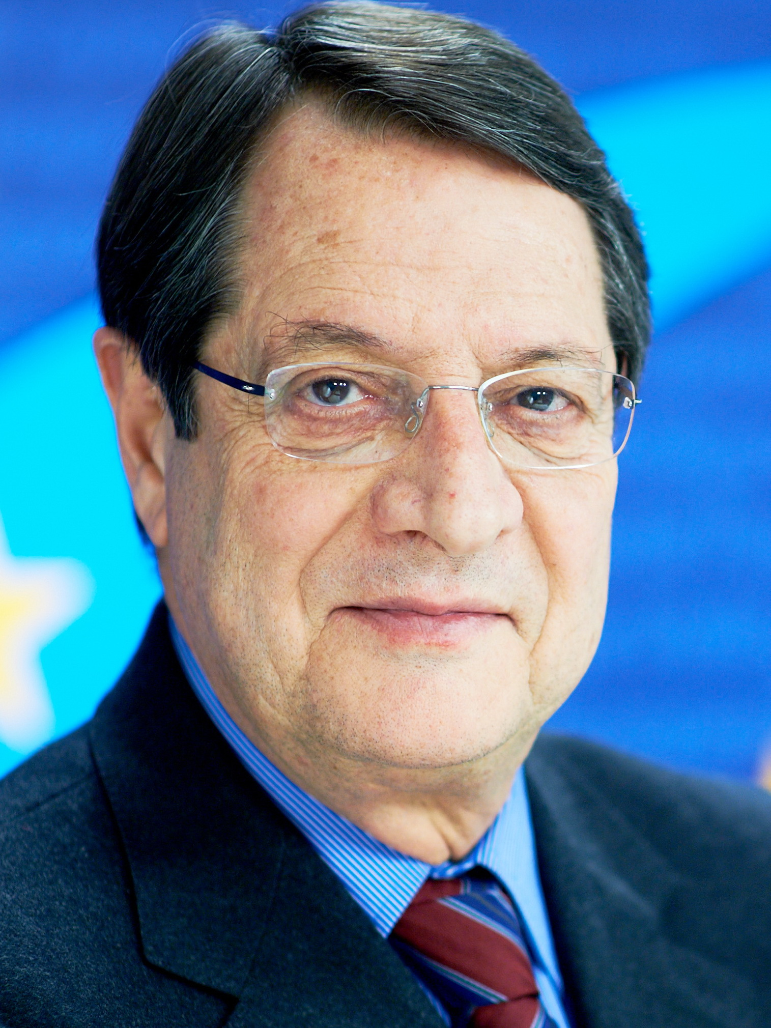 | 28 February 2013 | Incumbent | Democratic Rally

